Spencer Chapple
Abstract
#tbi
Key Terms – robotics, engineering,

Introduction
TBD
{{! Use this as an opportunity to describe the process of looking for a project and choosing what I did. }}
I'm beyond excited for my capstone project in this Spring semester of 2024, my last semester before graduation. This project is the first time I've been truly untethered with a project, thanks in large part to the Sherrat Library's generosity in awarding me the CONNECT grant to fund my project. For the first time, I have full control over the ideation, design, prototyping, fabrication, and assembly of a complex engineering problem incorporating all the things I am most interested in. Most significant, however, is the opportunity this project gives me to prove to myself and potential employers my value as a creative engineer.

Personal Criteria
With such high expectations and a 14-week time limit, I had to choose a project that would fit my criteria and not be more than I could accomplish within the semester. I had many ideas, but I knew the project had to be (1) interesting for me, (2) complex enough to be a challenge, but simple enough to fit within the time frame, and (3) an accurate representation of my capabilities as an engineer.

Making the Decision
So what project could encapsulate the abilities of a soon-to-be graduated Electromechanical Engineer and aspiring Inventor? A project that incorporated both electrical and mechanical systems. One that also made heavy use of my background in software engineering and my knowledge of mechanical and electrical phenomena. A robot relies on all these things--it is, by nature an amalgam of the mechanical, electrical, and software worlds.
So as I considered the various options I had from building a scale smart home to designing a autonomous vertical garden, I settled on designing a robotic arm as it seemed to fit best with all my criteria: I have a deep interest in robotics, the project would be complex enough to be a challenge, but It would still fit within the allotted time given that I’d have various resources throughout the world to turn to for inspiration and ideas. Last but not least, it would be an apt showcase of my skills and abilities as an up-and-coming engineer in the realm of expertise that I want to be a part of the most.
{{! It would be good to describe further what “realm” this is and that the particular area within that realm that I find myself in will be subject to change e.g. I could go toward industrial or commercial or consumer, etc. }}

{{! summarize the remainder of the proposal }}

Outline of the Proposal
The remainder of this proposal goes into further detail on the following subjects:
why I chose this particular project and the reasoning behind it
- An overview of the project as a whole, including my goals for what it will be able to do when complete and how I plan to make it work
- A block diagram as a visual aid for the project description/overview showing the relationships between the different parts of the system
- A timetable for completion of different aspects of the project
- A project cost estimate and projected budget/expenses, including a few details about the funds from the CONNECT grant.

Rationale
Why did I choose to engineer a robotic arm? Why not do something else, something simpler that would get the grade? A few main reasons come to mind, namely: (1) I wanted a challenge, but something feasible within the time we're given {{! explain later why it's feasible within the time constraints }}. (2) I wanted a project that would be tailored to my interests and aligned with the kind of work I'd like to do in my career {{! That would be a mixture of computer and hands-on work: CAD design, 3d printing, prototyping, assembly, machining, etc. Additionally, it encapsulates electronics, mechanical systems, and software into a robotics platform--a realm of technology I am deeply interested in }}. (3) For reasons of educational, professional, and personal advancement and development.

{{! *From [[Application Essays#^f4f1fd]], [[Application Essays#^8130db]], and [[Application Essays#^da8133]]* }}
Educationally, my capstone project will allow me to realize the knowledge I've gathered throughout my college career in the form of a physical, real-world project. I'll be able to solidify what I've learned and gain a deeper understanding of the concepts that drive mechanical, electrical, and software engineering.
Professionally, my capstone project will serve as proof to prospective employers not only of my abilities and skills but also of my passion for engineering and my strong work ethic. I want my capstone to be the first of many examples of what I can accomplish when allowed the opportunity.
Personally, my capstone project will allow me to prove to myself that I am capable of solving complex engineering problems. I believe strongly that I am capable of doing anything I set my mind to, and I am eager for this new challenge that encapsulates the things I am most passionate about in engineering. By completing this project, my in-class knowledge will become experience and understanding which will allow me to proceed through life and career with even greater confidence and passion than before.
{{! *from [[Application Essays#Moving Beyond]]* }}
With the mechanical design of my project, I'll have the opportunity to actualize a physical embodiment of the theoretical principles, a complex integration of the robot's frame and supporting actuators. The ambitious aspect lies in the intricacies of these actuators, involving sophisticated gear reduction, meticulous consideration of motor torque, and RPM, pushing the boundaries of what is typically undertaken in this domain.

In the realm of electrical design, this project offers a chance to transcend classroom theories by immersing myself in the intricacies of a real-world electrical assembly. It represents more than just a theoretical exercise; it's a tangible demonstration of my ability to grapple with and solve challenging electrical problems using an advanced understanding, a leap beyond conventional coursework.
Software design, the heartbeat of the project, necessitates the creation of intricate programs to orchestrate the electromechanical systems, conduct complex mathematical calculations, and interpret and respond to video input through machine learning. This ambitious undertaking goes beyond typical classroom projects, pushing the boundaries of software engineering and AI integration.
In essence, I aim to carry the skills and knowledge cultivated in this project throughout my career, transforming it into a cornerstone for future endeavors. This endeavor goes beyond the norm; it encapsulates the essence of my love and passion for engineering, reflecting a commitment to excellence and a determination to leave an indelible mark in my field.
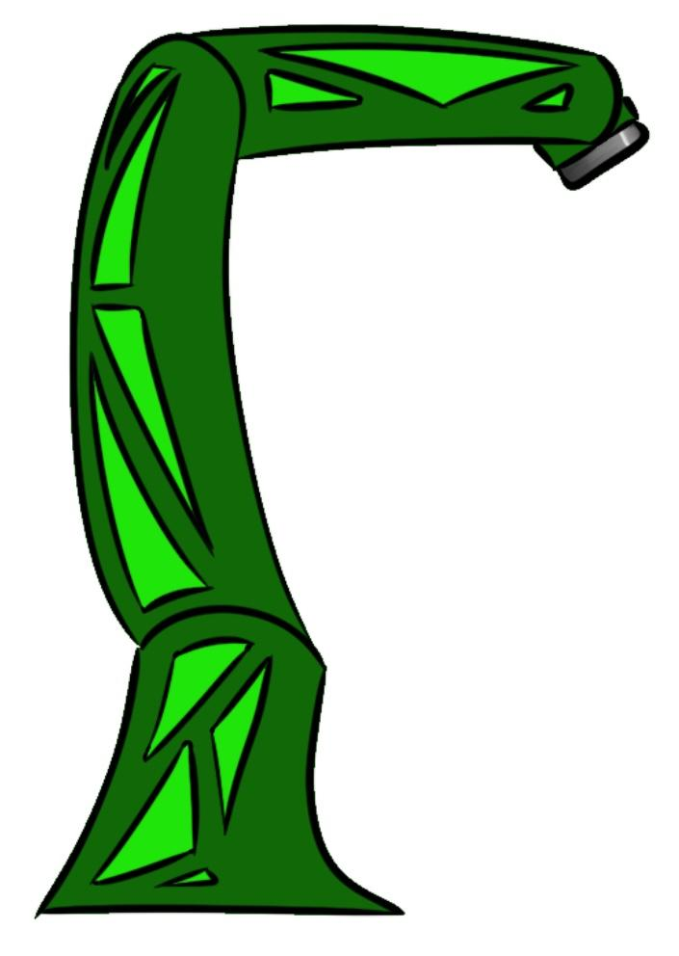
Figure 1. Early concept art of the robotic arm.

Description
{{! *from [[Application Essays#Project Abstract]]* }}

For my Spring semester capstone project, I will design and build a custom robotic arm, integrating Mechanical Design, Electrical Design, and Software Design. This comprehensive project is an opportunity to showcase my skills and zeal for engineering to potential employers.

For mechanical design, I'll focus on designing a sturdy yet manageable frame and robust actuators (motors combined with gearboxes and electronics) capable of empowering the robot to manipulate small objects without mechanical failure.

The electrical design of the arm will involve determining power requirements, selecting appropriate hardware, and managing wiring for a clean system. The key for all these electrical systems to work together will be finding the optimal Single Board Computer (SBC) to act as the brain of the entire system, which must be capable of interfacing with all the various actuators, sensors, motor drivers, etc.

For the software design, I will be incorporating ROS (Robot Operating System) as the programming framework, planning a clean and well-rounded software structure, and utilizing Python machine vision (Artificial Intelligence) libraries for intelligent reactions.

To achieve this, I will use the break to research ROS, Python machine learning libraries, and design requirements/specifications for motors and controllers. The start of the semester to midterm will be used to finalize the design, begin prototyping, and commence software and electronics work. During the latter half of the semester, I will focus on finalizing the design, assembling components, completing software development, and preparing for project presentation.

Block Diagram
{{! ![[Education and Learning/Capstone/project proposal/Drafts/attachments/block diagram|1000]] }}
#draft

Time Table/Schedule
#tbi

Cost Estimate
{{! *From [[Application Essays#Budget Narrative]]* }}
The budget spreadsheet outlines essential components crucial for the project's successful execution. These components, ranging from the single-board computer to motors, motor drivers, and materials for structure and prototyping, are indispensable for building the robot. The CONNECT grant plays a pivotal role in realizing this ambitious project by providing vital financial support.

In addition to grant funding, proactive steps have been taken to optimize costs. Engaging with various organizations has yielded positive results, with ODrive offering a generous 25% discount on their products, enhancing the affordability of critical components.

Furthermore, strategic collaboration with the Engineering Technology Faculty not only keeps them informed about the project but also aims to secure additional funding. Exploring various funding options demonstrates a proactive approach to resource management.

Signature Sheet

Spencer Chapple, Southern Utah University, College of Engineering and Computational Sciences

